**React JS HOL**

**1.React JS HOL-9:**

**Code:**

import './App.css';

import ListOfPlayers from './Components/ListOfPlayers';

import {DisplayIndianPlayers} from './Components/IndianPlayers';

import { OddPlayers } from './Components/OddPlayers';

import { EvenPlayers } from './Components/EvenPlayers';

function App() {

  const flag=true;

   const players=[

           { name: "Jack", score: 50 },

    { name: "Michael", score: 70 },

    { name: "John", score: 40 },

    { name: "Ann", score: 61 },

    { name: "Elisabeth", score: 61 },

    { name: "Sachin", score: 95 },

    { name: "Dhoni", score: 100 },

    { name: "Virat", score: 84 },

    { name: "Jadeja", score: 64 },

    { name: "Raina", score: 75 },

    { name: "Rohit", score: 80 }

        ];

    const IndianPlayers=[

      {name: "Sachin",id:1},

      {name: "Dhoni",id:2},

      {name: "Virat",id:3},

      {name: "Rohit",id:4},

      {name: "Yuvraj",id:5},

      {name: "Raina",id:6}

    ]

     if(flag===true) { return(<ListOfPlayers players={players}/>);}

     else {

      return(

        <div>

      <h1>Odd Players</h1>

      {OddPlayers(IndianPlayers)}

      <h1>Even Players</h1>

      {EvenPlayers(IndianPlayers)}

      <h1>List of Indian Players Merged</h1>

     <DisplayIndianPlayers IndianPlayers={IndianPlayers}/>

     </div>

    );

  }

}

export default App;

export default function ListOfPlayers({players}) {

   const players70=players.filter(players=>players.score<=70);

  return (

    <div>

    <h1>List of Players</h1>

    {players.map((item)=>(

            <div>

                <li>Mr.{item.name} <span> {item.score} </span></li>

            </div>

    ))}

    <hr />

    <h1>List of players having scores less than 70</h1>

    {players70.map((item)=>(

            <li> Mr.{item.name} <span> {item.score} </span></li>

    ))}

  </div>

  );

};

export function OddPlayers([first,, third,, fifth]){

    return(

        <div>

            <li>First:{first}</li>

            <li>Third:{third}</li>

            <li>Fifth:{fifth}</li>

        </div>

    );

}

export function EvenPlayers([second,, fourth,, sixth]){

    return(

        <div>

            <li>Second:{second}</li>

            <li>Fourth:{fourth}</li>

            <li>Sixth:{sixth}</li>

        </div>

    );

}

const T20Players= ['First Player', 'Second Player', 'Third Player'];

const RanjiTrophyPlayers = ['Fourth Player', 'Fifth Player', 'Sixth Player'];

export const DisplayIndianPlayers = [...T20Players, ...RanjiTrophyPlayers];

**Output:**

**a) Var=true**

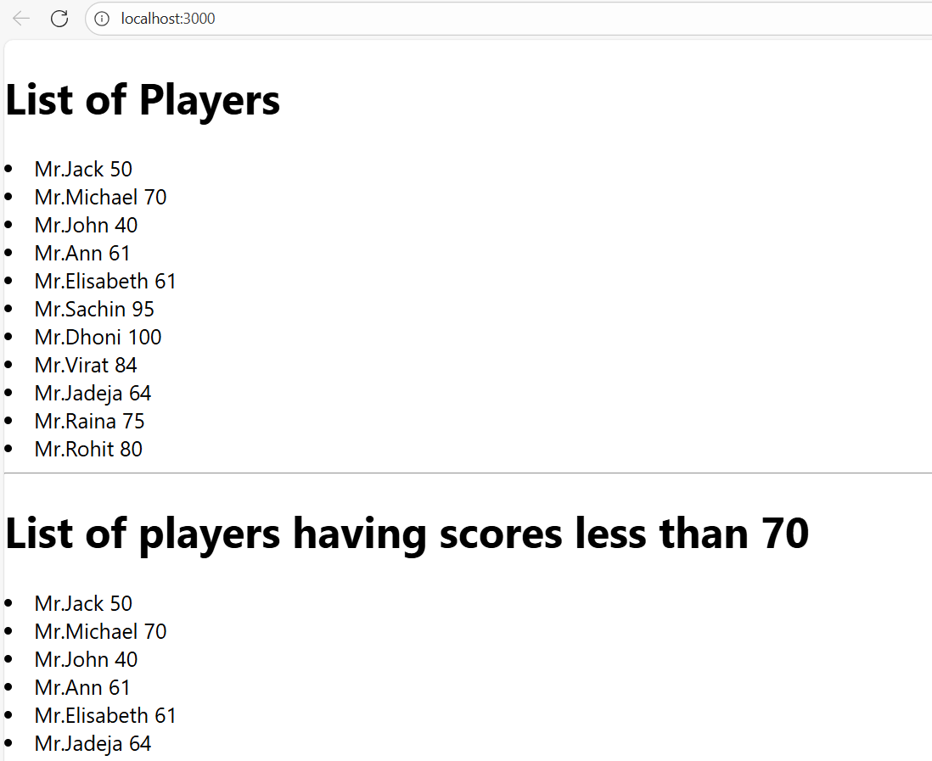

**b) Var=false**

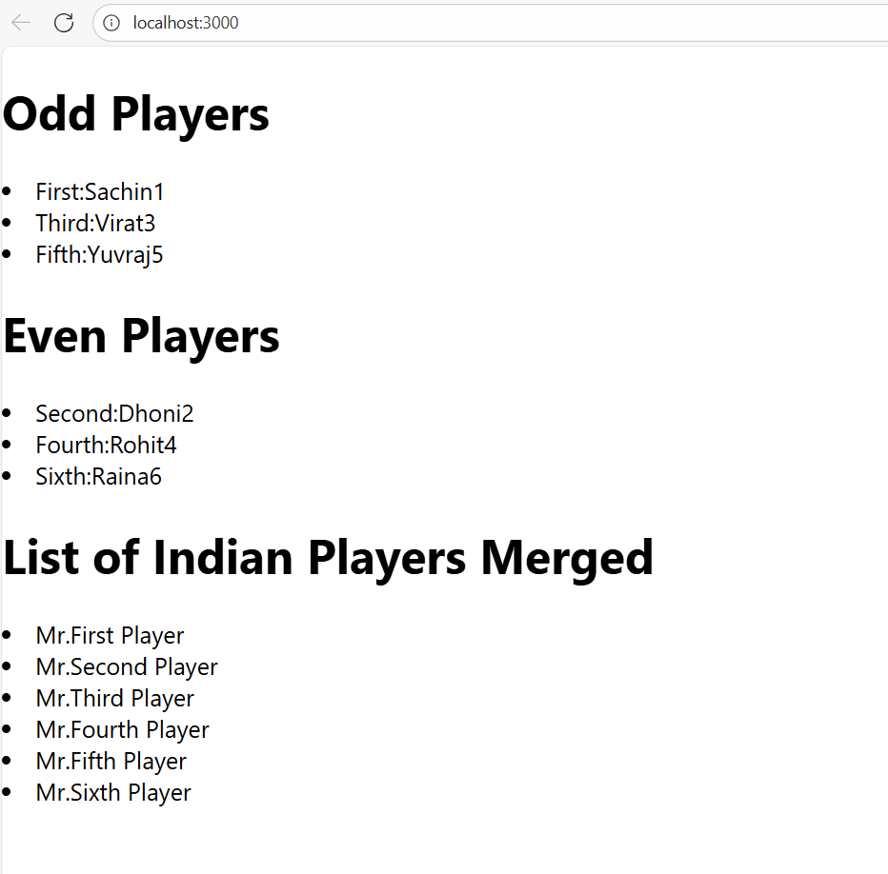

**2.React JS HOL-10:**

**Code:**

import './App.css';

function App() {

  const officeSpaces = [

    {

      id: 1,

      name: "TechHub Space",

      rent: 55000,

      address: "MG Road, Pune",

      image: "https://i.pinimg.com/originals/e3/cf/e1/e3cfe105113c9ab6d1a581169faa9cfe.jpg"

    },

    {

      id: 2,

      name: "StartUp Nest",

      rent: 75000,

      address: "HSR Layout, Bangalore",

      image: "https://chiedesign.in/wp-content/uploads/2022/05/Luxury-Interior-Design-Living-Room.jpg"

    },

    {

      id: 3,

      name: "Office Hive",

      rent: 62000,

      address: "Koregaon Park, Pune",

      image: "https://design-authority.com/wp-content/uploads/2021/09/Modern-Luxury-Interior-Design-by-Fusion-Design-Limited-1.jpg"

    },

    {

      id: 4,

      name: "Eco Work Pods",

      rent: 48000,

      address: "Cyber City, Gurgaon",

      image: "https://i.pinimg.com/originals/b7/a1/f2/b7a1f2238828717382c8174410ca0815.jpg"

    }

  ];

  return(

    <div className='App'>

      <h1>Office Space, at Affordable Range</h1>

      {officeSpaces.map((office)=>(

        <div>

        <img src={office.image} className='office-img'/>

        <h3>Name : {office.name}</h3>

        <h3 style={{color:office.rent<=60000? "red":"green"}}>Rent : {office.rent}</h3>

        <h3>Address : {office.address}</h3>

        <br />

        </div>

      ))}

    </div>

  );

}

export default App;

**Output:**



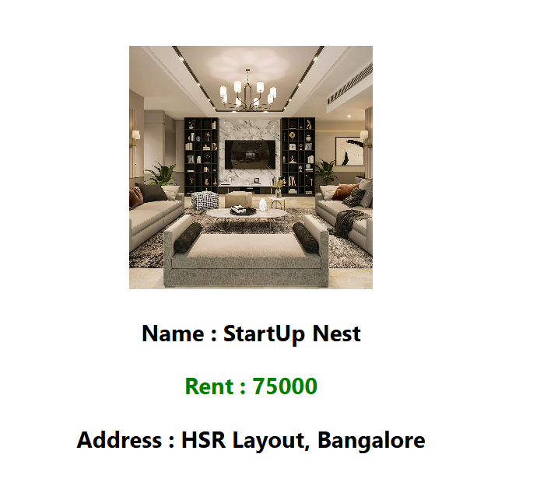

**3. React JS HOL-11:**

**Code:**

function App() {

  const[count,setCount] =useState(0);

  const increment=()=>{

       setCount(count=>count+1);

       sayHello();

  }

  const decrement=()=>{

       setCount(count=>count-1);

       sayHello();

  }

  const sayHello=()=>{

    alert("Hello Member!");

  }

  const saywelcome=(message)=>{

    alert(message);

  }

  const onPress=()=>{

    alert("I was clicked");

  }

  return(

    <>

    <div>

      <h2>Count Value : {count}</h2>

      <Button onClick={increment} style={{ marginTop: '15px' }}>Increment</Button>

      <br />

      <Button onClick={decrement} style={{ marginTop: '15px' }}>Decrement</Button>

      <br />

      <Button onClick={()=>saywelcome("Welcome!")} style={{ marginTop: '15px' }}>Say Welcome</Button>

      <br />

      <Button onClick={onPress} style={{ marginTop: '15px' }}>Click Me</Button>

      <br />

    </div>

    <CurrencyConverter/>

    </>

  );

}

export default App;

export default function CurrencyConverter() {

    const[rupees,setRupees]=useState('');

    const[euro,setEuro]=useState('');

    const convert=()=>{

        const euro=parseFloat(rupees)/90;

        setEuro(euro.toFixed(3));

    }

  return (

    <div>

      <h1>Currency Converter</h1>

      <label>Amount : </label>

       <input type="number" placeholder="Enter value in Rupees" onChange={(e)=>setRupees(e.target.value)} />

       <Button onClick={convert} style={{ marginLeft: '15px' }}>Convert</Button>

       <br />

       <label style={{ marginTop: '15px' }}>Converted Amount : </label>

       <input style={{ marginTop: '15px' }} type="number" value={euro} disabled/>

    </div>

  )

}

**Output:**

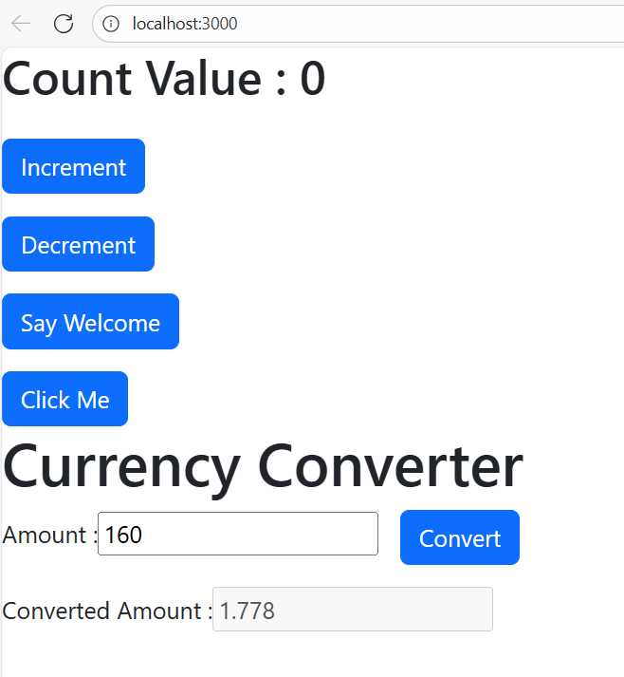

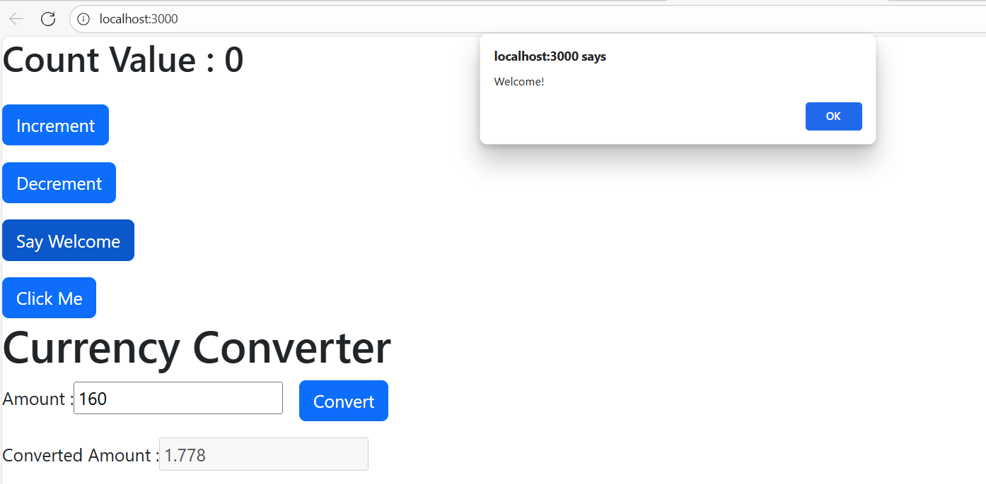

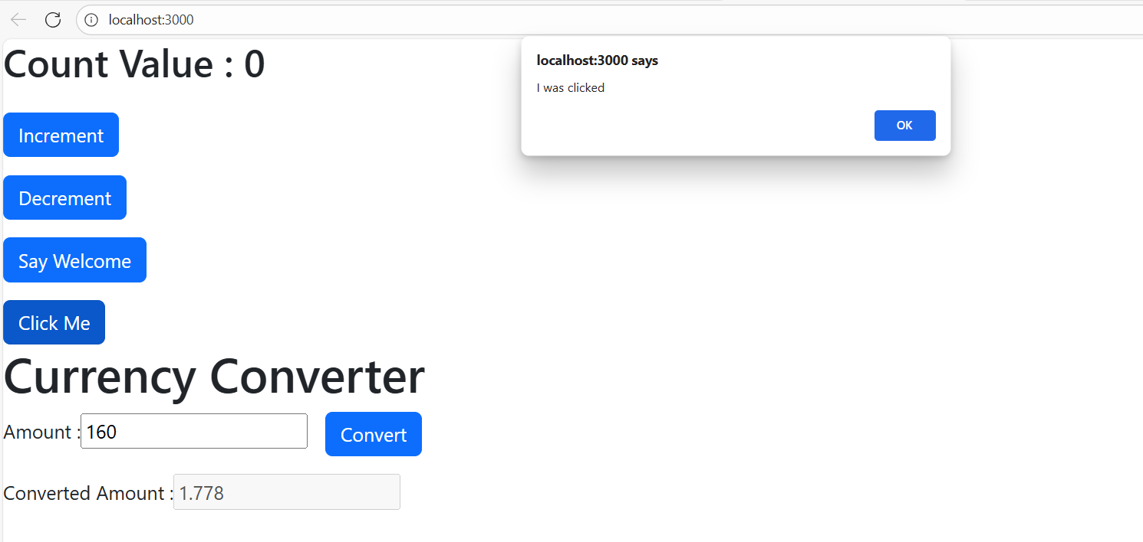

**4. React JS HOL-12:**

**Code:**

function App() {

  const[log,setLog] = useState(false);

  const toggle = ()=>{

    if(log===false) {

      setLog(true);

    }

    else {

      setLog(false);

    }

  }

  return(

    <>

    <div className='App'>

       <h1>{log? "Welcome User":"Please sign up"}</h1>

       <Button onClick={toggle}>{log? "Logout":"Login"}</Button>

       <br />

       <Flights isLogged={log}/>

    </div>

    </>

  );

}

export default App;

export default function Flights(props) {

    const flight=[

        {

            id:1,

            from:"Nagpur",

            to:"Delhi"

        },

        {

            id:2,

            from:"Chennai",

            to:"Mumbai"

        },

        {

            id:3,

            from:"Kolkata",

            to:"Delhi"

        },

        {

            id:4,

            from:"Hyderabad",

            to:"Lucknow"

        },

    ]

  return (

    <div>

      {flight.map((f)=>(

        <li id={f.id} style={{margin:10}}>From : {f.from} To : {f.to}</li>

      ))}

      {props.isLogged && <Button>Book Flights</Button>}

    </div>

  );

}

**Output:**

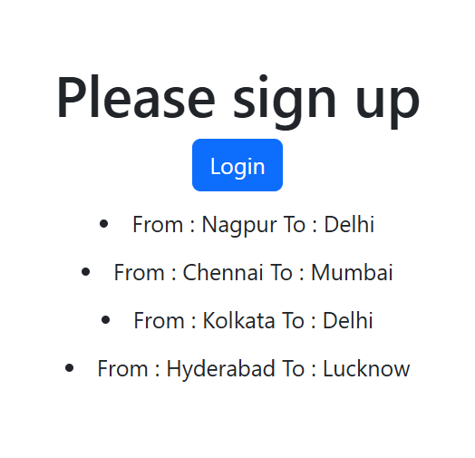

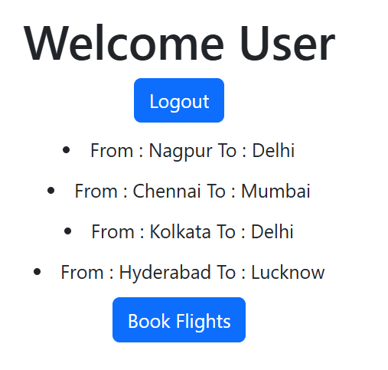

**5. React JS HOL-13:**

**Code:**

function App() {

  const[option,setOption]=new useState('');

  let o;

  if(option==='book'){

    o=<Book/>

  }else if(option==='blog'){

    o=<Blog/>

  }else{

    o=<Course/>

  }

  return(

    <>

   {o}

    </>

  );

}

export default function Book() {

    const books = [

  { title: "Master React", price: 670 },

  { title: "Deep Dive into Angular 11", price: 800 },

  { title: "Mongo Essentials", price: 450 }

];

  return (

    <div className='App'>

      <h1>Book Details</h1>

      {books.map((b)=>(

        <>

        <h3>{b.title}</h3>

        <p>{b.price}</p>

        </>

      ))}

    </div>

  )

}

export default function Blog() {

    const blogs = [

  {

    title: "React Learning",

    author: "Stephen Biz",

    content: "Welcome to learning React!"

  },

  {

    title: "Installation",

    author: "Schwezdenier",

    content: "You can install React from npm."

  }

];

  return (

    <div className='App'>

        <h1>Blog Details</h1>

      {blogs.map((b)=>(

        <>

        <h3>{b.title}</h3>

        <p>{b.author}</p>

        <p>{b.content}</p>

        </>

      ))}

    </div>

  )

}

export default function Course() {

    const courses = [

  { title: "Angular", date: "4/5/2021" },

  { title: "React", date: "6/3/2021" }

];

  return (

    <div className="App">

        <h1>Course details</h1>

      {courses.map((f)=>(

        <div>

         <h3>{f.title}</h3>

         <p>{f.date}</p>

         </div>

      ))}

    </div>

  )

}

**Output:**

